Supplementary Dataset S2, Related to Figure 2. E. coli GREs discovered in EGRIN 2.0.
Column descriptions:

- GRE index
- Number of cis-regulatory motifs in the GRE motif cluster
- Location of peak in distribution of locations of GRE relative to translation start sites of genes (as plotted in Supplementary Figure 3B)
- Best transcription factor match from experimentally mapped TFBS in RegulonDB
- FDR q-value for significance of transcription factor match in column (4)
- Fraction of cis-regulatory motifs in the GRE motif cluster with significant matches to the transcription factor listed in column (4)
- Motif logo of GRE

GRE | N.motifs | Location | RDB.Match | RDB.Match.Qval | RDB.Match.Fraction | Logo
1 | 1502 | 20.7 |  | NA | NA | 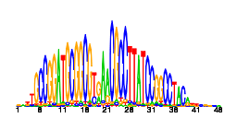
2 | 435 | 74.9 |  | NA | NA | 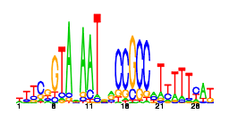
3 | 420 | 75.2 | Fur | 0 | 0.97 | 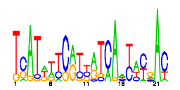
4 | 331 | 57.9 | PurR | 0 | 0.99 | 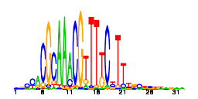
5 | 320 | 51.7 | ArcA | 2.6e-111 | 0.62 | 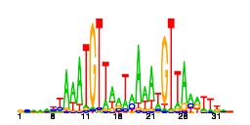
6 | 317 | 72.5 |  | NA | NA | 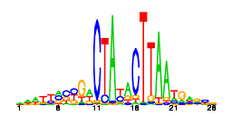
7 | 285 | 102.0 |  | NA | NA | 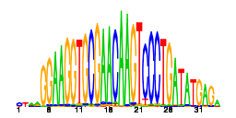
8 | 258 | 24.4 | CytR | 1.9e-57 | 0.28 | 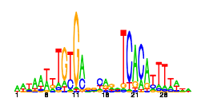
9 | 250 | 84.3 |  | NA | NA | 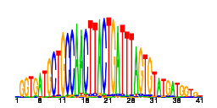
10 | 213 | 41.3 |  | NA | NA | 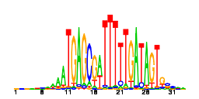
12 | 210 | 69.6 | ArgR | 0 | 1 | 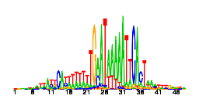
13 | 184 | 83.3 |  | NA | NA | 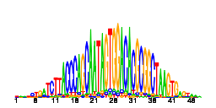
14 | 174 | 111.1 |  | NA | NA | 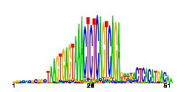
15 | 152 | 45.6 |  | NA | NA | 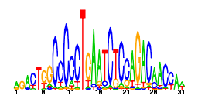
16 | 146 | 20.0 | GadE | 0 | 0.95 | 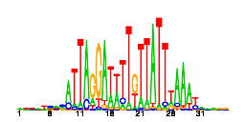
17 | 143 | 115.7 |  | NA | NA | 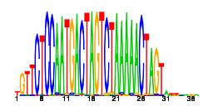
18 | 142 | 40.7 | FNR | 1.9e-100 | 0.87 | 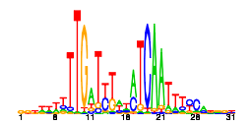
19 | 120 | 53.5 | MetJ | 4.2e-252 | 0.97 | 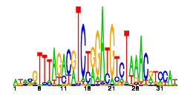
20 | 102 | 18.7 |  | NA | NA | 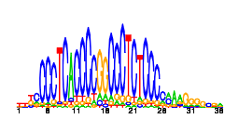
21 | 98 | 54.5 | FlhDC | 1.8e-99 | 0.8 | 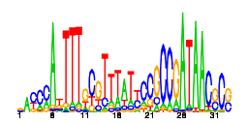
22 | 92 | 95.9 |  | NA | NA | 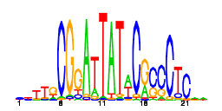
23 | 85 | 46.9 |  | NA | NA | 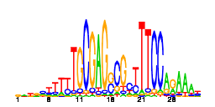
24 | 83 | 20.8 |  | NA | NA | 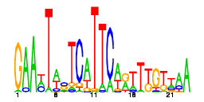
25 | 81 | 51.6 | MelR | 1.7e-07 | 0.11 | 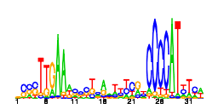
26 | 77 | 71.1 |  | NA | NA | 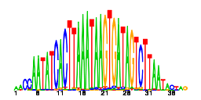
27 | 74 | 111.4 |  | NA | NA | 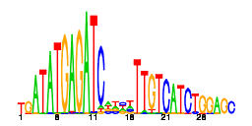
28 | 73 | 66.1 |  | NA | NA | 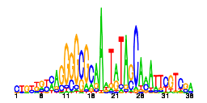
29 | 71 | 68.4 |  | NA | NA | 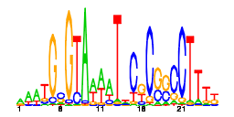
30 | 69 | 71.8 | IclR | 1.4e-09 | 0.17 | 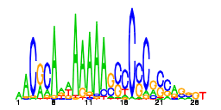
31 | 67 | 71.3 | NarP | 1.3e-21 | 0.34 | 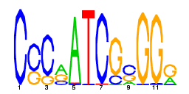
32 | 61 | 84.4 |  | NA | NA | 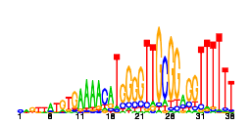
33 | 60 | 18.2 |  | NA | NA | 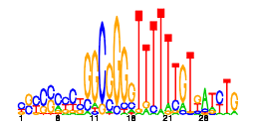
34 | 57 | 46.3 | MalT | 6.5e-102 | 0.98 | 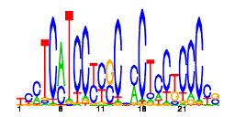
35 | 54 | 20.4 | GadW | 8.1e-74 | 0.87 | 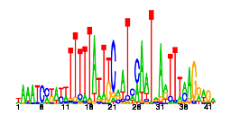
36 | 53 | 37.2 |  | NA | NA | 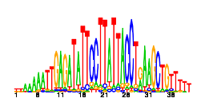
37 | 51 | 71.7 |  | NA | NA | 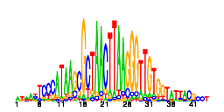
38 | 51 | 33.7 | PhoB | 0.003 | 0.18 | 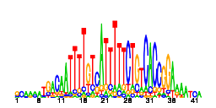
39 | 50 | 89.7 |  | NA | NA | 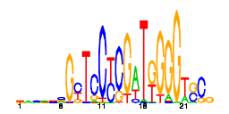
40 | 48 | 79.7 |  | NA | NA | 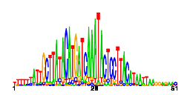
41 | 47 | 73.2 |  | NA | NA | 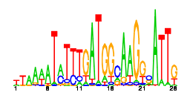
42 | 45 | 82.8 | LexA | 1.1e-60 | 0.98 | 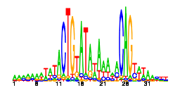
43 | 45 | 91.9 |  | NA | NA | 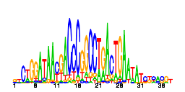
44 | 45 | 19.9 | FruR | 9.2e-71 | 0.93 | 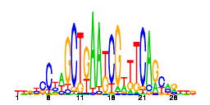
45 | 45 | 15.0 | GntR | 4.4e-08 | 0.22 | 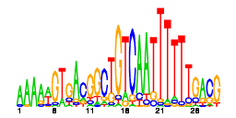
47 | 43 | 24.0 |  | NA | NA | 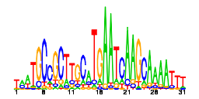
48 | 43 | 13.5 |  | NA | NA | 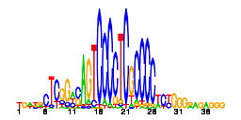
49 | 43 | 12.8 | UlaR | 0.0022 | 0.12 | 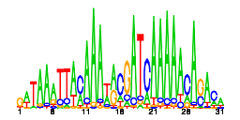
50 | 43 | 22.3 | CysB | 1.6e-06 | 0.28 | 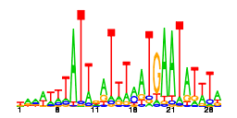
51 | 41 | 73.4 | RcsB | 1.8e-54 | 0.88 | 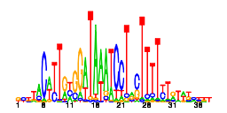
52 | 40 | 42.0 |  | NA | NA | 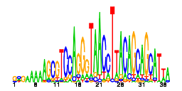
54 | 39 | 41.0 |  | NA | NA | 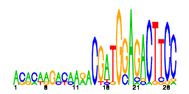
55 | 39 | 70.3 |  | NA | NA | 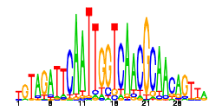
56 | 39 | 58.2 | CynR | 2.4e-05 | 0.13 | 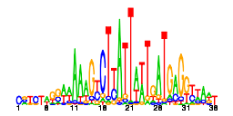
57 | 38 | 12.8 | NrdR | 1e-05 | 0.13 | 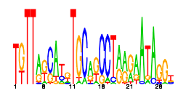
58 | 38 | 65.8 | CueR | 9.5e-81 | 0.92 | 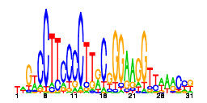
59 | 37 | 37.1 |  | NA | NA | 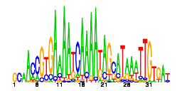
60 | 36 | 71.0 |  | NA | NA | 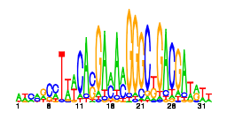
61 | 36 | 76.5 |  | NA | NA | 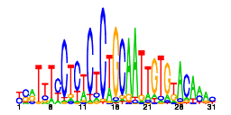
63 | 35 | 30.6 | FlhDC | 3.9e-28 | 0.71 | 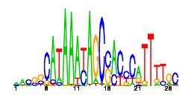
64 | 35 | 32.8 |  | NA | NA | 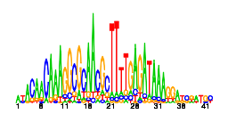
65 | 35 | 77.3 |  | NA | NA | 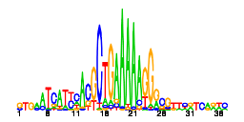
66 | 34 | 16.3 | FlhDC | 8.4e-27 | 0.71 | 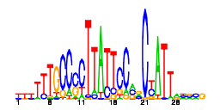
67 | 34 | 32.7 | RhaS | 5.3e-06 | 0.15 | 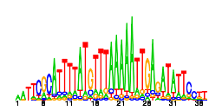
68 | 33 | 18.4 |  | NA | NA | 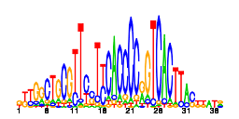
69 | 32 | 45.7 |  | NA | NA | 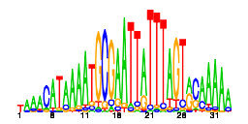
71 | 31 | 78.6 | OxyR | 3.5e-08 | 0.42 | 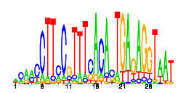
73 | 31 | 38.9 |  | NA | NA | 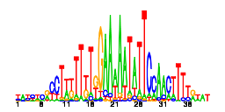
74 | 31 | 15.2 |  | NA | NA | 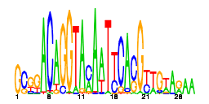
75 | 31 | 104.7 |  | NA | NA | 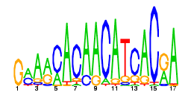
76 | 30 | 101.1 |  | NA | NA | 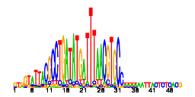
77 | 30 | 43.4 |  | NA | NA | 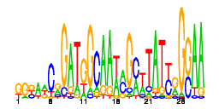
78 | 30 | 70.0 |  | NA | NA | 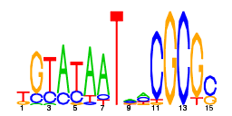
79 | 30 | 14.3 |  | NA | NA | 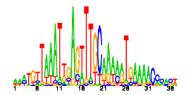
80 | 30 | 58.7 |  | NA | NA | 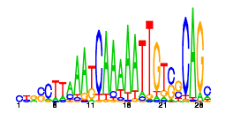
81 | 29 | 29.0 |  | NA | NA | 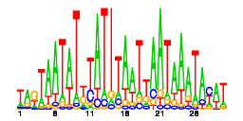
82 | 29 | 16.4 |  | NA | NA | 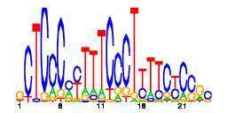
83 | 29 | 26.5 | UlaR | 0.0043 | 0.14 | 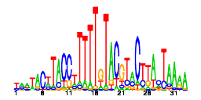
84 | 29 | 22.8 |  | NA | NA | 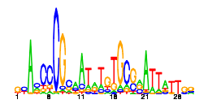
85 | 29 | 26.7 |  | NA | NA | 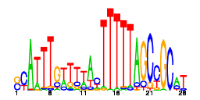
87 | 28 | 23.2 | MetJ | 0.0033 | 0.18 | 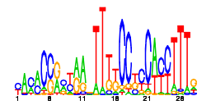
88 | 27 | 9.2 |  | NA | NA | 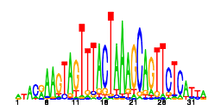
89 | 27 | 47.0 |  | NA | NA | 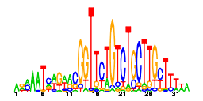
90 | 27 | 69.8 |  | NA | NA | 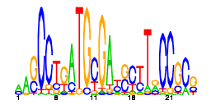
91 | 27 | 45.3 |  | NA | NA | 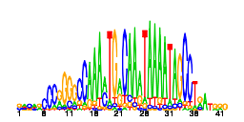
92 | 27 | 82.9 |  | NA | NA | 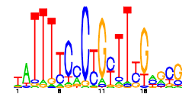
93 | 27 | 62.9 |  | NA | NA | 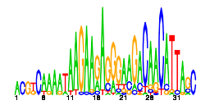
94 | 27 | 45.6 |  | NA | NA | 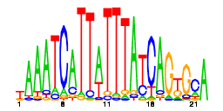
95 | 26 | 58.5 | CysB | 2e-27 | 0.85 | 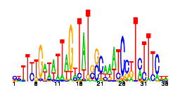
96 | 26 | 81.5 |  | NA | NA | 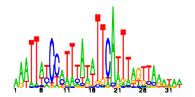
97 | 26 | 46.9 |  | NA | NA | 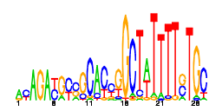
98 | 25 | 35.6 |  | NA | NA | 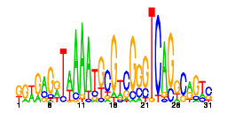
99 | 25 | 24.7 |  | NA | NA | 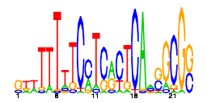
100 | 25 | 58.9 |  | NA | NA | 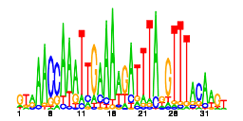
101 | 24 | 13.4 |  | NA | NA | 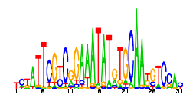
102 | 24 | 14.4 | MalT | 5.1e-06 | 0.29 | 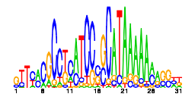
103 | 24 | 93.2 | FlhDC | 5.4e-30 | 0.92 | 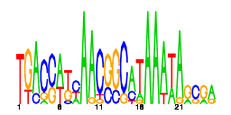
104 | 24 | 43.8 |  | NA | NA | 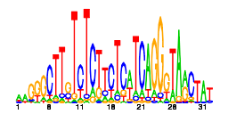
105 | 24 | 90.0 | Zur | 0.00049 | 0.17 | 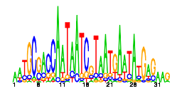
106 | 24 | 76.5 |  | NA | NA | 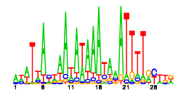
107 | 24 | 69.7 |  | NA | NA | 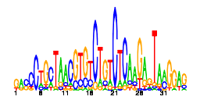
108 | 24 | 76.1 | NarL | 7.6e-11 | 0.62 | 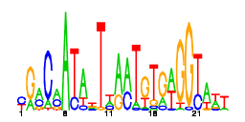
109 | 24 | 31.8 |  | NA | NA | 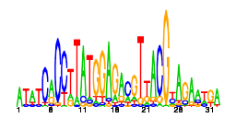
110 | 23 | 9.2 |  | NA | NA | 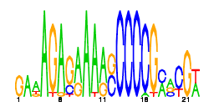
113 | 23 | 25.7 |  | NA | NA | 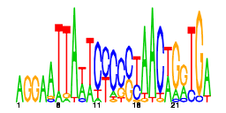
114 | 23 | 47.6 |  | NA | NA | 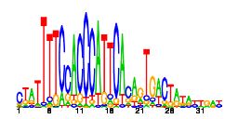
115 | 23 | 25.8 |  | NA | NA | 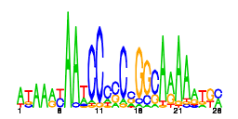
116 | 23 | 60.4 | MngR | 1.4e-18 | 0.52 | 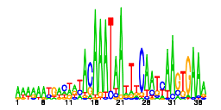
117 | 23 | 93.3 |  | NA | NA | 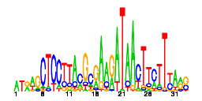
118 | 23 | 17.5 |  | NA | NA | 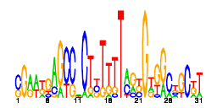
119 | 22 | 105.1 | ArgR | 7.6e-27 | 0.95 | 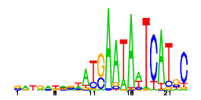
120 | 21 | 16.9 | AsnC | 0.016 | 0.14 | 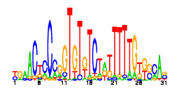
121 | 21 | 17.7 |  | NA | NA | 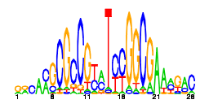
122 | 21 | 72.8 |  | NA | NA | 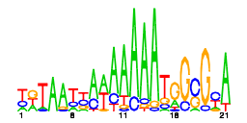
123 | 21 | 51.1 |  | NA | NA | 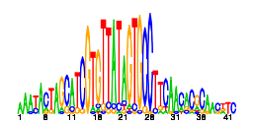
124 | 21 | 25.8 | OxyR | 0.013 | 0.29 | 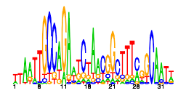
125 | 21 | 16.3 |  | NA | NA | 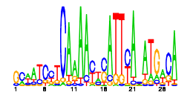
126 | 21 | 80.8 |  | NA | NA | 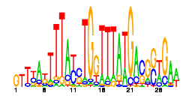
127 | 21 | 68.6 |  | NA | NA | 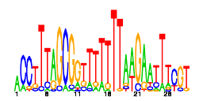
128 | 21 | 84.7 |  | NA | NA | 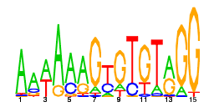
129 | 21 | 51.1 |  | NA | NA | 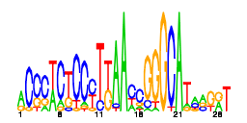
130 | 21 | 29.0 |  | NA | NA | 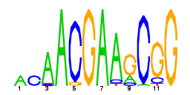
131 | 20 | 49.8 | CysB | 1.9e-26 | 0.95 | 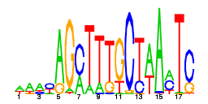
133 | 20 | 25.5 |  | NA | NA | 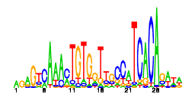
134 | 20 | 48.7 | CytR | 7.1e-06 | 0.35 | 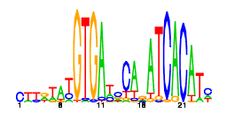
135 | 20 | 40.6 |  | NA | NA | 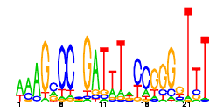
136 | 20 | 84.9 |  | NA | NA | 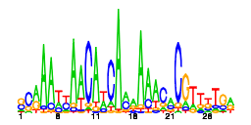
137 | 20 | 44.2 |  | NA | NA | 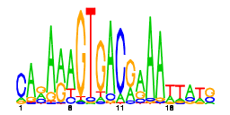
139 | 19 | 89.9 |  | NA | NA | 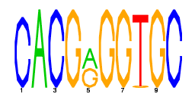
140 | 19 | 55.9 |  | NA | NA | 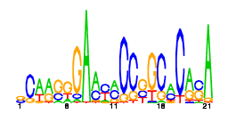
141 | 19 | 70.6 |  | NA | NA | 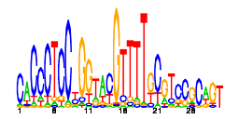
142 | 19 | 16.9 |  | NA | NA | 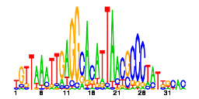
143 | 19 | 19.1 |  | NA | NA | 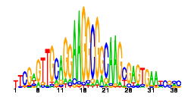
144 | 19 | 19.3 |  | NA | NA | 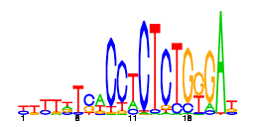
145 | 19 | 46.8 |  | NA | NA | 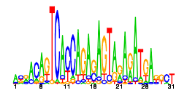
146 | 19 | 30.6 | RutR | 4.7e-35 | 0.89 | 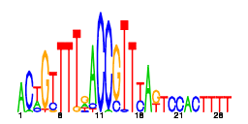
147 | 19 | 74.4 |  | NA | NA | 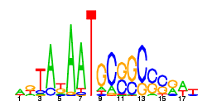
148 | 19 | 14.4 |  | NA | NA | 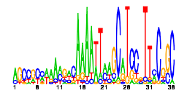
149 | 19 | 40.7 |  | NA | NA | 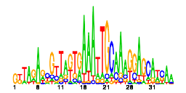
151 | 18 | 57.0 |  | NA | NA | 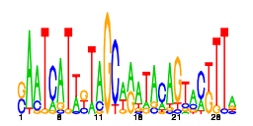
152 | 18 | 44.6 | GadW | 0.0096 | 0.22 | 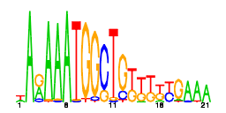
153 | 18 | 9.3 |  | NA | NA | 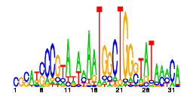
154 | 18 | 65.8 |  | NA | NA | 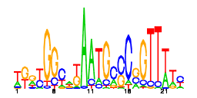
156 | 18 | 43.2 |  | NA | NA | 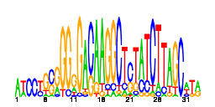
157 | 18 | 15.5 |  | NA | NA | 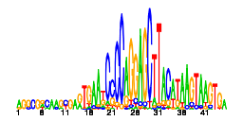
158 | 18 | 56.2 |  | NA | NA | 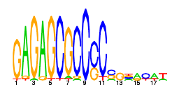
159 | 18 | 73.8 |  | NA | NA | 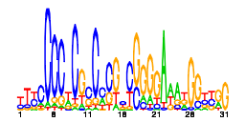
160 | 18 | 52.0 |  | NA | NA | 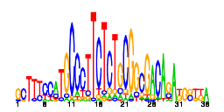
161 | 18 | 70.5 |  | NA | NA | 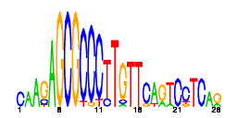
162 | 18 | 20.6 |  | NA | NA | 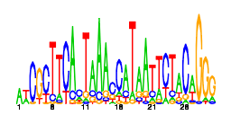
163 | 18 | 148.1 | TrpR | 2.3e-22 | 0.67 | 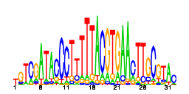
164 | 18 | 34.6 |  | NA | NA | 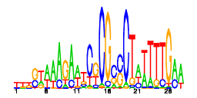
165 | 18 | 13.9 |  | NA | NA | 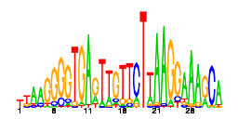
166 | 18 | 21.1 |  | NA | NA | 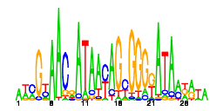
167 | 17 | 13.2 | FlhDC | 1.5e-17 | 0.82 | 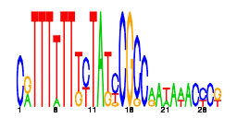
168 | 17 | 79.4 |  | NA | NA | 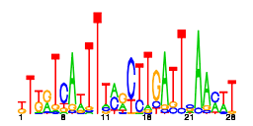
169 | 17 | 98.8 | IscR | 0.0072 | 0.24 | 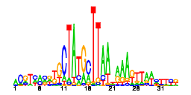
171 | 17 | 94.5 |  | NA | NA | 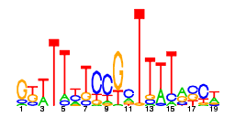
172 | 17 | 79.7 | UlaR | 6.2e-18 | 0.65 | 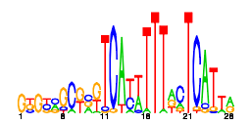
173 | 17 | 33.7 |  | NA | NA | 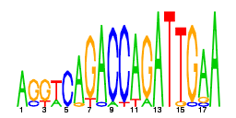
174 | 17 | 56.3 |  | NA | NA | 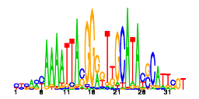
175 | 17 | 44.7 |  | NA | NA | 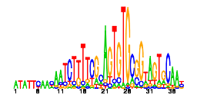
176 | 16 | 70.4 |  | NA | NA | 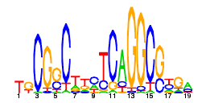
177 | 16 | 68.8 |  | NA | NA | 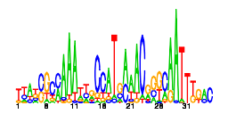
178 | 16 | 22.9 | FlhDC | 0 | 1 | 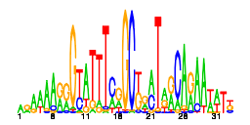
179 | 16 | 63.6 | FruR | 0.0039 | 0.25 | 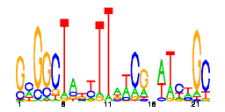
180 | 16 | 86.0 |  | NA | NA | 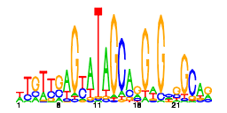
181 | 16 | 98.0 |  | NA | NA | 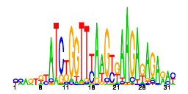
182 | 16 | 30.2 |  | NA | NA | 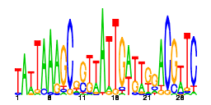
183 | 16 | 73.5 |  | NA | NA | 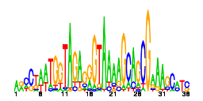
184 | 16 | 45.9 |  | NA | NA | 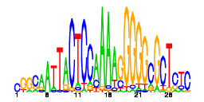
185 | 16 | 73.9 | IscR | 1.1e-21 | 0.88 | 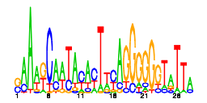
186 | 16 | 37.8 |  | NA | NA | 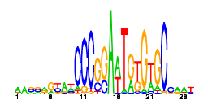
187 | 16 | 26.6 |  | NA | NA | 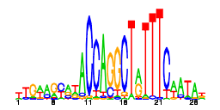
188 | 16 | 10.3 |  | NA | NA | 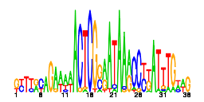
189 | 16 | 67.2 | CysB | 0.0049 | 0.31 | 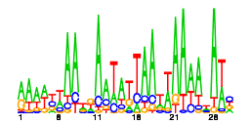
190 | 16 | 79.3 |  | NA | NA | 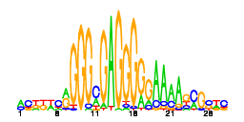
191 | 16 | 34.5 | NsrR | 0.0054 | 0.38 | 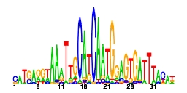
192 | 16 | 61.8 |  | NA | NA | 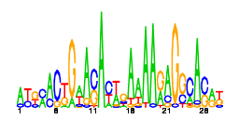
193 | 16 | 75.7 |  | NA | NA | 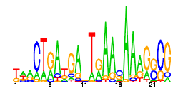
194 | 16 | 12.9 | IdnR | 0.0073 | 0.12 | 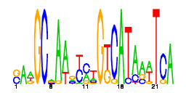
195 | 16 | 95.0 |  | NA | NA | 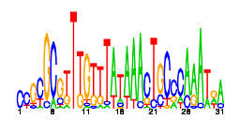
196 | 15 | 62.9 |  | NA | NA | 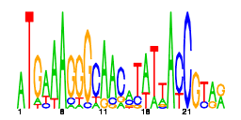
197 | 15 | 77.9 |  | NA | NA | 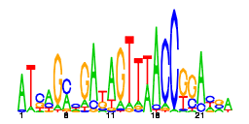
198 | 15 | 32.8 |  | NA | NA | 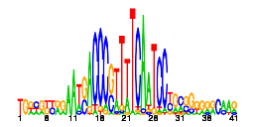
199 | 15 | 71.3 |  | NA | NA | 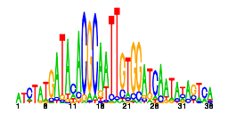
200 | 15 | 18.0 | AraC | 1.7e-05 | 0.33 | 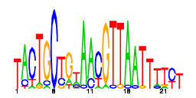
201 | 15 | 56.0 |  | NA | NA | 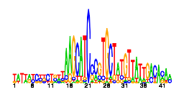
202 | 15 | 54.6 | MprA | 5.6e-33 | 0.87 | 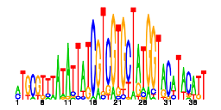
203 | 15 | 13.4 | EvgA | 0.0053 | 0.13 | 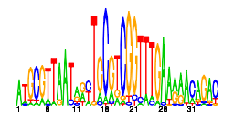
204 | 15 | 16.2 | NarL | 4.8e-05 | 0.53 | 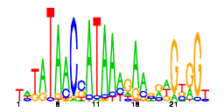
205 | 15 | 73.9 |  | NA | NA | 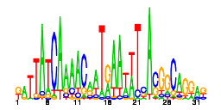
206 | 15 | 89.6 |  | NA | NA | 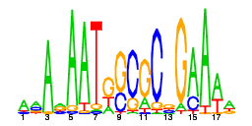
207 | 15 | 81.5 |  | NA | NA | 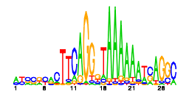
208 | 14 | 69.0 | CysB | 2.6e-15 | 0.86 | 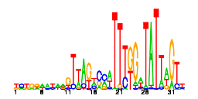
209 | 14 | 60.1 |  | NA | NA | 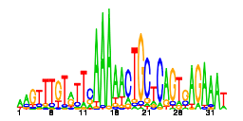
210 | 14 | 21.2 |  | NA | NA | 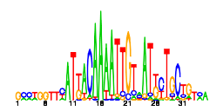
211 | 14 | 52.2 |  | NA | NA | 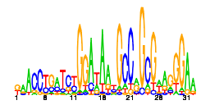
212 | 14 | 20.6 |  | NA | NA | 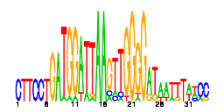
213 | 14 | 102.6 |  | NA | NA | 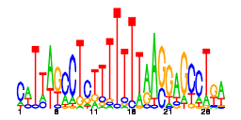
214 | 14 | 59.7 |  | NA | NA | 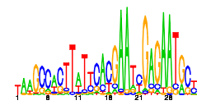
215 | 14 | 19.5 | FhlA | 0 | 1 | 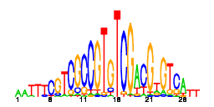
216 | 14 | 22.2 | H-NS | 0.014 | 0.36 | 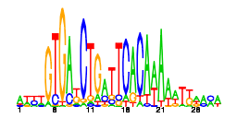
217 | 14 | 25.6 |  | NA | NA | 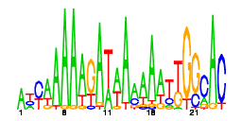
218 | 14 | 38.1 |  | NA | NA | 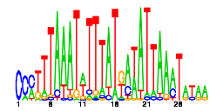
219 | 14 | 84.0 |  | NA | NA | 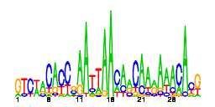
220 | 14 | 59.7 |  | NA | NA | 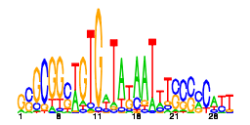
221 | 14 | 21.3 |  | NA | NA | 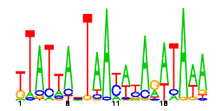
222 | 14 | 13.4 |  | NA | NA | 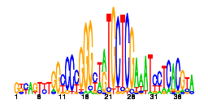
223 | 14 | 31.3 |  | NA | NA | 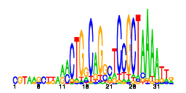
224 | 14 | 86.1 |  | NA | NA | 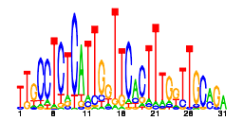
225 | 14 | 39.8 |  | NA | NA | 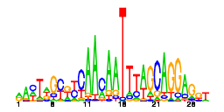
226 | 14 | 89.0 |  | NA | NA | 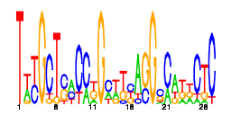
227 | 14 | 90.4 |  | NA | NA | 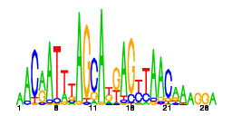
228 | 14 | 79.1 |  | NA | NA | 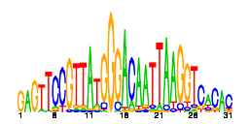
229 | 14 | 36.3 |  | NA | NA | 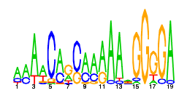
230 | 13 | 98.4 |  | NA | NA | 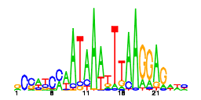
232 | 13 | 13.4 |  | NA | NA | 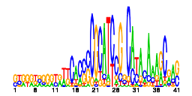
233 | 13 | 55.3 |  | NA | NA | 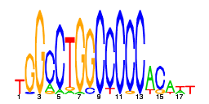
234 | 13 | 63.7 |  | NA | NA | 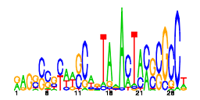
236 | 13 | 57.0 |  | NA | NA | 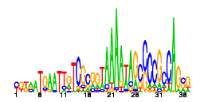
237 | 13 | 40.9 |  | NA | NA | 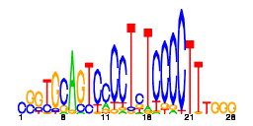
238 | 13 | 53.2 |  | NA | NA | 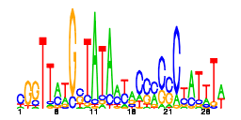
239 | 13 | 33.9 |  | NA | NA | 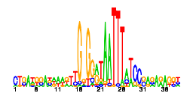
240 | 13 | 109.7 |  | NA | NA | 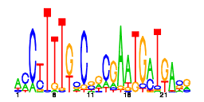
241 | 13 | 15.4 |  | NA | NA | 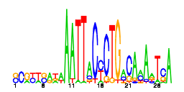
242 | 13 | 86.2 |  | NA | NA | 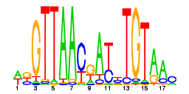
243 | 13 | 44.4 |  | NA | NA | 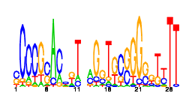
244 | 13 | 73.6 |  | NA | NA | 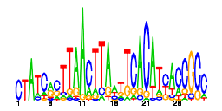
245 | 13 | 72.1 |  | NA | NA | 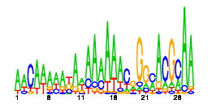
246 | 13 | 75.5 | Zur | 2.1e-09 | 0.46 | 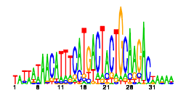
247 | 13 | 66.3 |  | NA | NA | 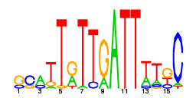
248 | 13 | 72.4 |  | NA | NA | 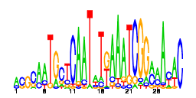
249 | 13 | 41.4 |  | NA | NA | 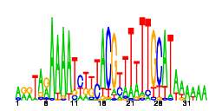
250 | 13 | 77.1 |  | NA | NA | 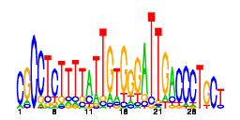
251 | 13 | 48.1 | AscG | 0.011 | 0.15 | 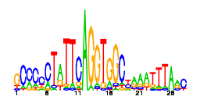
252 | 13 | 17.6 |  | NA | NA | 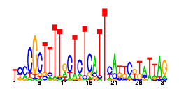
253 | 13 | 42.8 |  | NA | NA | 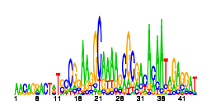
254 | 13 | 81.3 |  | NA | NA | 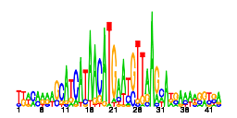
255 | 13 | 27.4 | RutR | 1.9e-05 | 0.31 | 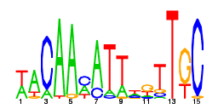
257 | 13 | 62.9 |  | NA | NA | 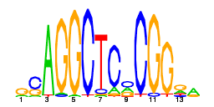
259 | 12 | 55.2 |  | NA | NA | 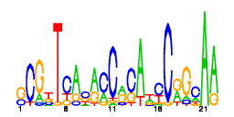
261 | 12 | 65.3 | OxyR | 0.038 | 0.33 | 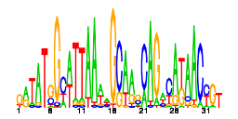
262 | 12 | 116.4 | DeoR | 5.8e-07 | 0.33 | 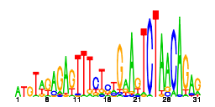
263 | 12 | 66.2 |  | NA | NA | 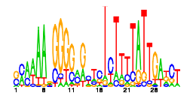
264 | 12 | 54.7 |  | NA | NA | 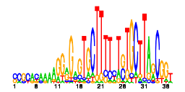
265 | 12 | 20.1 | RcsB | 0.0018 | 0.33 | 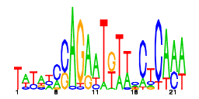
266 | 12 | 93.5 |  | NA | NA | 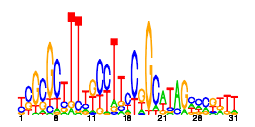
267 | 12 | 84.4 |  | NA | NA | 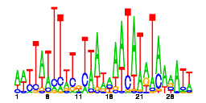
268 | 12 | 95.9 |  | NA | NA | 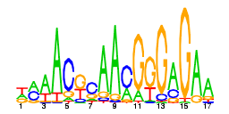
269 | 12 | 14.5 | FlhDC | 1.9e-05 | 0.5 | 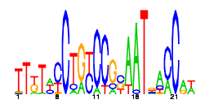
270 | 12 | 100.1 |  | NA | NA | 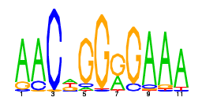
271 | 12 | 67.7 |  | NA | NA | 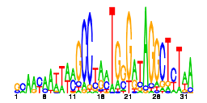
272 | 12 | 79.9 | IdnR | 0.0032 | 0.17 | 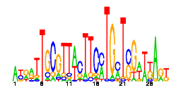
273 | 12 | 13.8 |  | NA | NA | 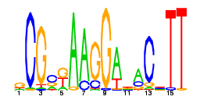
274 | 12 | 87.6 | PhoB | 0.0094 | 0.33 | 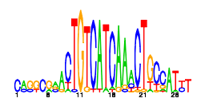
275 | 12 | 67.2 |  | NA | NA | 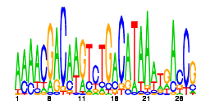
276 | 12 | 67.6 |  | NA | NA | 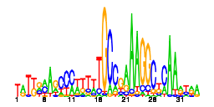
277 | 12 | 51.4 |  | NA | NA | 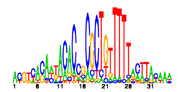
278 | 12 | 59.1 |  | NA | NA | 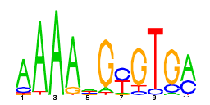
279 | 12 | 73.7 |  | NA | NA | 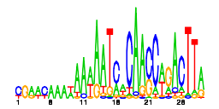
280 | 12 | 14.0 | MalT | 0 | 1 | 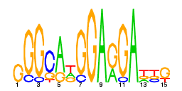
281 | 12 | 71.0 |  | NA | NA | 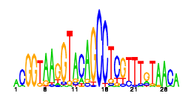
283 | 12 | 20.4 | OxyR | 3.3e-11 | 0.83 | 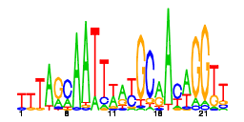
284 | 12 | 58.3 |  | NA | NA | 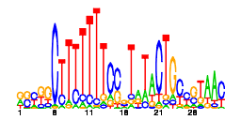
285 | 12 | 35.0 |  | NA | NA | 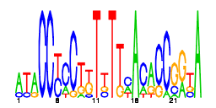
286 | 12 | 97.3 | EvgA | 2.3e-05 | 0.25 | 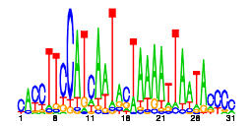
287 | 12 | 88.7 |  | NA | NA | 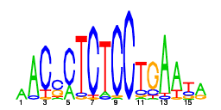
288 | 12 | 74.7 |  | NA | NA | 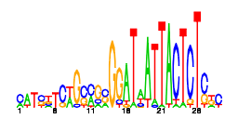
289 | 12 | 68.4 |  | NA | NA | 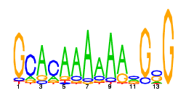
291 | 11 | 35.3 | Lrp | 0 | 1 | 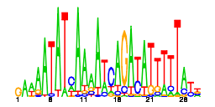
292 | 11 | 25.5 |  | NA | NA | 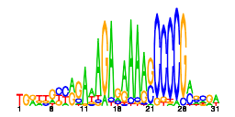
293 | 11 | 23.4 |  | NA | NA | 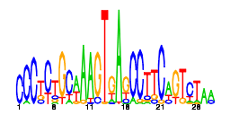
294 | 11 | 61.0 | PurR | 4.4e-07 | 0.64 | 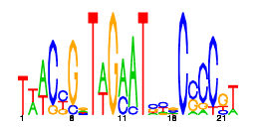
295 | 11 | 81.7 |  | NA | NA | 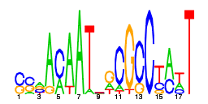
296 | 11 | 79.5 |  | NA | NA | 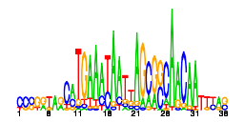
297 | 11 | 36.4 |  | NA | NA | 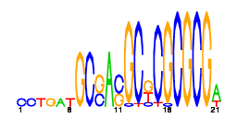
298 | 11 | 53.3 |  | NA | NA | 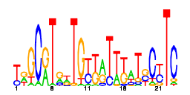
299 | 11 | 99.0 |  | NA | NA | 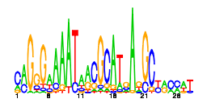
300 | 11 | 98.2 | SoxS | 3e-06 | 0.64 | 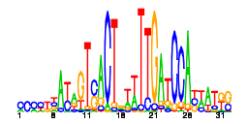
301 | 11 | 16.5 | Fur | 8.4e-11 | 0.91 | 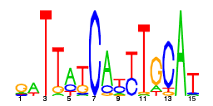
302 | 11 | 52.9 |  | NA | NA | 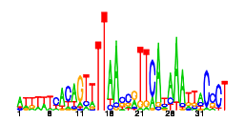
303 | 11 | 44.0 |  | NA | NA | 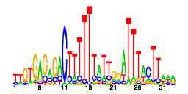
304 | 11 | 31.2 |  | NA | NA | 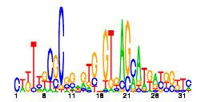
305 | 11 | 18.3 | UlaR | 5.7e-14 | 0.73 | 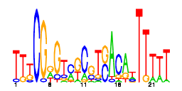
306 | 11 | 31.6 |  | NA | NA | 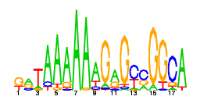
307 | 11 | 59.1 | TorR | 1.1e-10 | 0.73 | 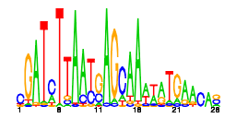
308 | 11 | 34.3 |  | NA | NA | 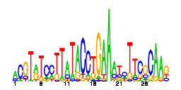
309 | 11 | 30.9 | Zur | 0.021 | 0.18 | 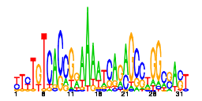
310 | 11 | 97.3 |  | NA | NA | 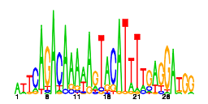
311 | 11 | 10.3 |  | NA | NA | 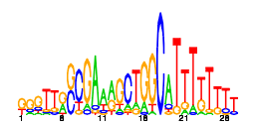
312 | 11 | 33.3 |  | NA | NA | 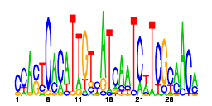
313 | 11 | 70.9 |  | NA | NA | 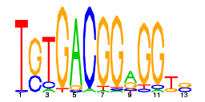
314 | 11 | 57.9 |  | NA | NA | 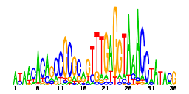
315 | 11 | 73.0 |  | NA | NA | 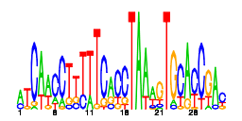
316 | 11 | 61.1 |  | NA | NA | 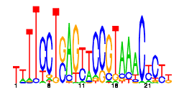
317 | 11 | 83.6 |  | NA | NA | 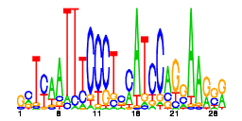
318 | 11 | 67.1 |  | NA | NA | 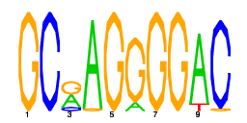
319 | 11 | 19.4 |  | NA | NA | 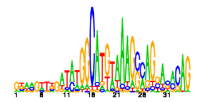
320 | 11 | 31.6 |  | NA | NA | 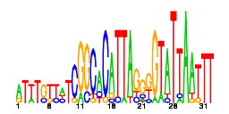
321 | 11 | 95.4 | Zur | 0 | 1 | 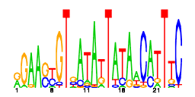
322 | 11 | 58.7 |  | NA | NA | 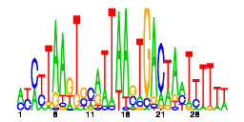
323 | 11 | 75.7 |  | NA | NA | 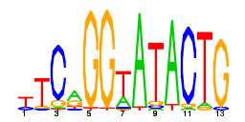
324 | 11 | 75.2 |  | NA | NA | 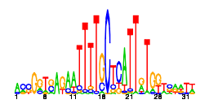
325 | 11 | 75.3 |  | NA | NA | 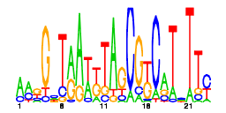
326 | 11 | 124.0 | GadW | 1.9e-05 | 0.45 | 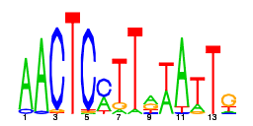
327 | 11 | 103.3 |  | NA | NA | 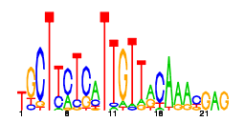
328 | 11 | 38.7 | NarL | 0 | 1 | 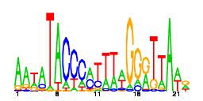
329 | 11 | 47.7 | NarL | 1.5e-08 | 0.82 | 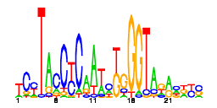
330 | 10 | 25.1 |  | NA | NA | 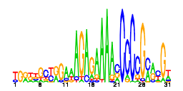
331 | 10 | 56.4 | RcsB | 0.016 | 0.3 | 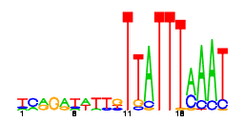
333 | 10 | 82.5 |  | NA | NA | 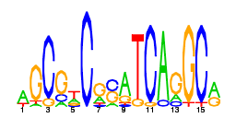
334 | 10 | 95.5 |  | NA | NA | 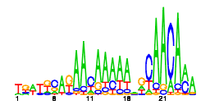
335 | 10 | 138.3 |  | NA | NA | 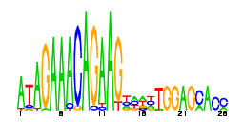
336 | 10 | 79.3 |  | NA | NA | 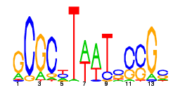
337 | 10 | 41.1 |  | NA | NA | 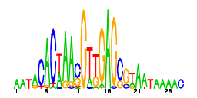
338 | 10 | 32.5 |  | NA | NA | 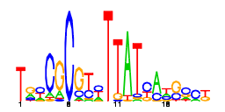
340 | 10 | 19.8 |  | NA | NA | 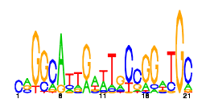
341 | 10 | 38.7 |  | NA | NA | 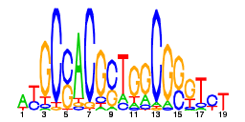
342 | 10 | 81.7 |  | NA | NA | 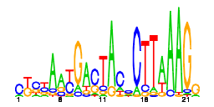
343 | 10 | 68.6 |  | NA | NA | 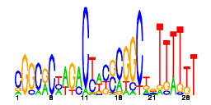
345 | 10 | 16.0 | FNR | 0.00027 | 0.7 | 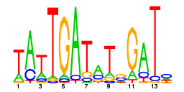
346 | 10 | 53.1 |  | NA | NA | 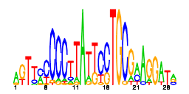
347 | 10 | 59.7 |  | NA | NA | 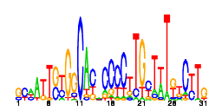
348 | 10 | 37.1 |  | NA | NA | 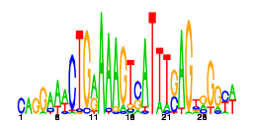
349 | 10 | 14.8 |  | NA | NA | 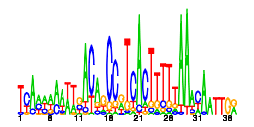
350 | 10 | 28.0 | GlpR | 8.1e-10 | 0.7 | 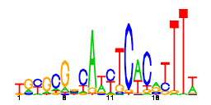
351 | 10 | 70.6 |  | NA | NA | 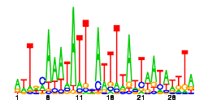
352 | 10 | 55.2 |  | NA | NA | 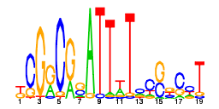
353 | 10 | 25.7 |  | NA | NA | 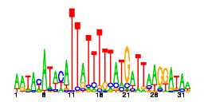
354 | 10 | 97.6 |  | NA | NA | 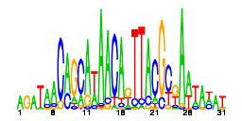
355 | 10 | 52.0 |  | NA | NA | 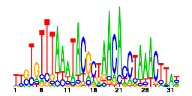
356 | 10 | 84.7 | AsnC | 0.03 | 0.2 | 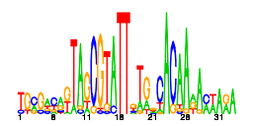
357 | 10 | 14.4 | MurR | 5.7e-17 | 0.8 | 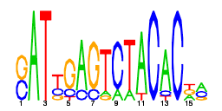
358 | 10 | 69.4 |  | NA | NA | 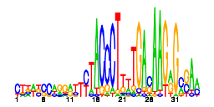
359 | 10 | 81.5 |  | NA | NA | 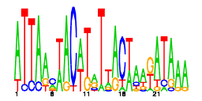
360 | 10 | 88.4 |  | NA | NA | 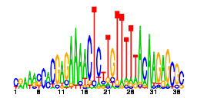
361 | 10 | 24.7 |  | NA | NA | 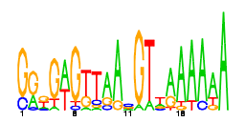
362 | 10 | 69.2 |  | NA | NA | 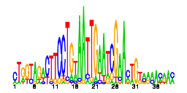
363 | 10 | 70.7 |  | NA | NA | 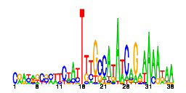
364 | 10 | 60.8 |  | NA | NA | 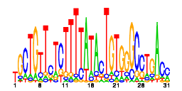
365 | 10 | 68.5 |  | NA | NA | 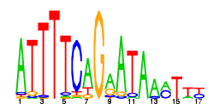
369 | 10 | 46.9 | CynR | 6.9e-21 | 0.9 | 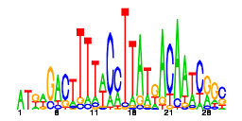
370 | 10 | 23.8 |  | NA | NA | 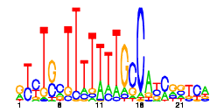
371 | 10 | 107.5 |  | NA | NA | 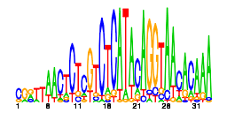
372 | 10 | 50.4 |  | NA | NA | 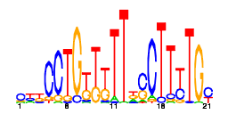
373 | 10 | 13.2 | OxyR | 0.016 | 0.4 | 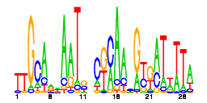
374 | 10 | 68.0 |  | NA | NA | 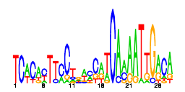
375 | 10 | 98.9 |  | NA | NA | 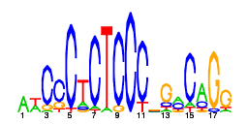
376 | 10 | 16.8 | NadR | 2e-06 | 0.3 | 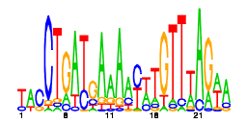
377 | 10 | 126.6 |  | NA | NA | 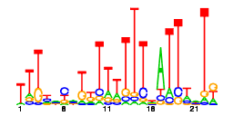
378 | 10 | 43.1 | XylR | 0.013 | 0.2 | 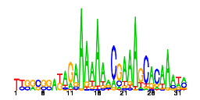
379 | 10 | 101.9 |  | NA | NA | 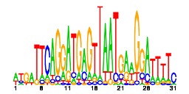
380 | 10 | 17.9 | DeoR | 0.0034 | 0.2 | 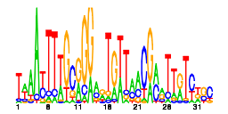
381 | 10 | 41.0 |  | NA | NA | 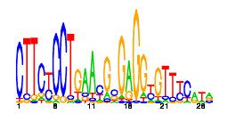
382 | 10 | 35.8 | MarA | 2.2e-08 | 0.8 | 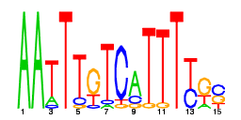
383 | 10 | 56.0 |  | NA | NA | 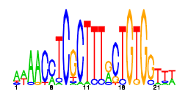
384 | 10 | 72.9 |  | NA | NA | 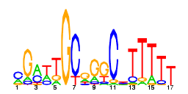
385 | 10 | 14.8 | UlaR | 1.5e-07 | 0.5 | 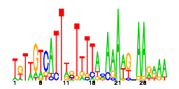
387 | 10 | 25.5 |  | NA | NA | 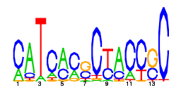
388 | 10 | 74.2 |  | NA | NA | 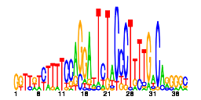
389 | 10 | 66.6 |  | NA | NA | 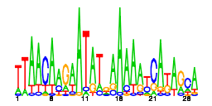
390 | 10 | 32.5 | NsrR | 0.031 | 0.4 | 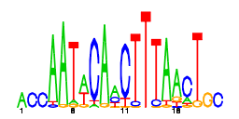
391 | 10 | 49.7 |  | NA | NA | 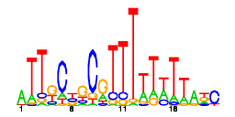
392 | 10 | 63.8 |  | NA | NA | 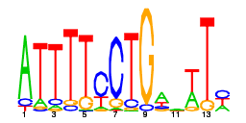
393 | 10 | 38.6 |  | NA | NA | 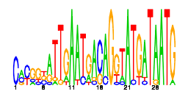
394 | 10 | 20.8 |  | NA | NA | 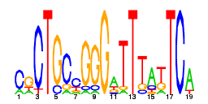
397 | 10 | 105.9 |  | NA | NA | 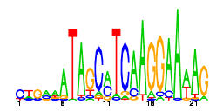
398 | 10 | 106.0 |  | NA | NA | 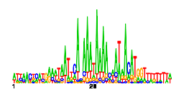
400 | 10 | 64.1 |  | NA | NA | 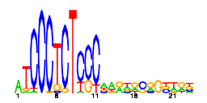
401 | 10 | 75.1 |  | NA | NA | 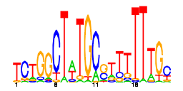
402 | 10 | 103.3 |  | NA | NA | 

